Latest News: 20th February 2021

by Mike Fonfe´

Christina and Michael’s Aussie Qualification Bonanza

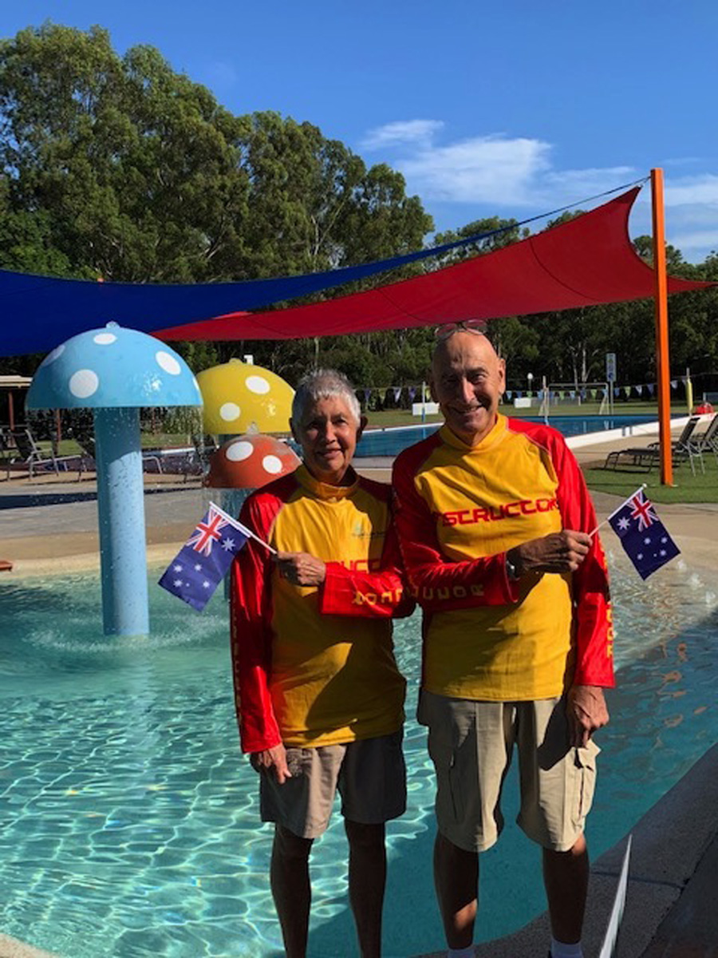
So now we are super-qualified septuagenarian swimming teachers
[Image 6]

It’s the day before my 76th birthday, when I’m bound to admit to a bit of excitement and it’s nothing to do with my age. A year and a week ago we both arrived in Australia to visit our recently married son. On the day before we were due to leave, the flights home were cancelled as the world locked down for the Covid-19 Pandemic. My son and new daughter-in-law insisted we stayed until it was safe to go home to England, so we found ourselves in Australia, as Boomerang Parents, still here today.

Queensland is lovely; the Coral Sea is gorgeous; the rural, coastal area is an explosion of exotic tropical flowers and creatures, while the municipality is appropriately called The Sunshine Coast. One day out exploring yet another fine beach we came across the tiny Ithaca Life Saving Club in Caloundra offering a free two-day so-called Grey Medallion first aid, water safety, rescue, CPR and AED course for the over 55’s run by the Royal Life Saving Society of Queensland RLSSQ, so we signed up for it right away. Turns out the course was being run by the mother of the CEO of RLSS Queensland. Well, I can only say it was brilliant.

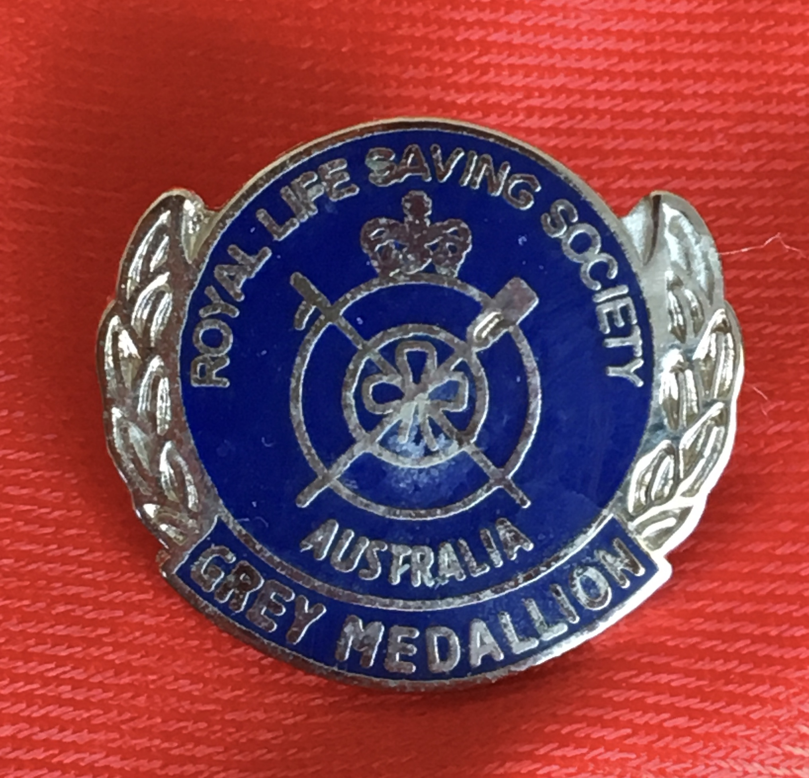
The RLSS Australia Grey Medallion

The Grey Medallion is like the Life Saving Bronze Medallion of our teenage days, except that it is aimed at over 55’s: grandparents who look after the grandchildren while mums and dads are away at work and older people taking part in aquatic activities themselves. As 80% of Australians live within 30 miles of the sea and 20% of homes have their own swimming pools, people head for the beach, pools and rivers for swimming, boating and fishing as favorite destinations. Add some extra hazards peculiar to Australia, such as flash floods in dry river beds, bridges without sides, bush fires when it’s dry, venomous stonefish, scorpion fish, jelly fish, cone shells and even a tiny, venomous, pretty little blue ringed octopus that lives in rock pools, first aid suddenly becomes very important to little ones as well as the elderly. We were so impressed, we decided that the course should be introduced to the UK (minus the octopus and cone shell below) and so did an additional course to qualify on an instructor’s course so that we can deliver it. Two RLSS courses done.

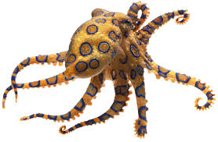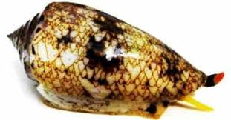
Either of these rock-pool dwellers, imaged here life-size, can put one into Hospital

Having attended several World Conferences on Drowning Prevention, it is fair for me to say that Australia is a world-leading force in drowning prevention. By sheer coincidence, the President of the International Federation of Swimming Teachers Associations IFSTA, Brendon Ward, is also the CEO of the Australia Swimming Teachers and Coaches Association ASCTA and Swim Australia with their offices just five miles down the road from us. After a long chat with Brendon, we decided to do the full Swim Australia swimming teachers course from scratch as if we were youngsters. I have to say it was thorough and brilliantly delivered. Because it’s a recognized vocational course with an educational credit rating, we had to register nationally as students and also get clearance for working with children. On completion of all this, one receives a license to teach swimming as well as conduct rescues, do CPR and operate an AED. Different to the UK STA and Swim England, AustSwim and RLSS, Swim Australia does not espouse a rigid Learn-to-Swim Certification Regime, but leaves it to individual swim schools to develop their own , in response to local and cultural needs. Three courses done.

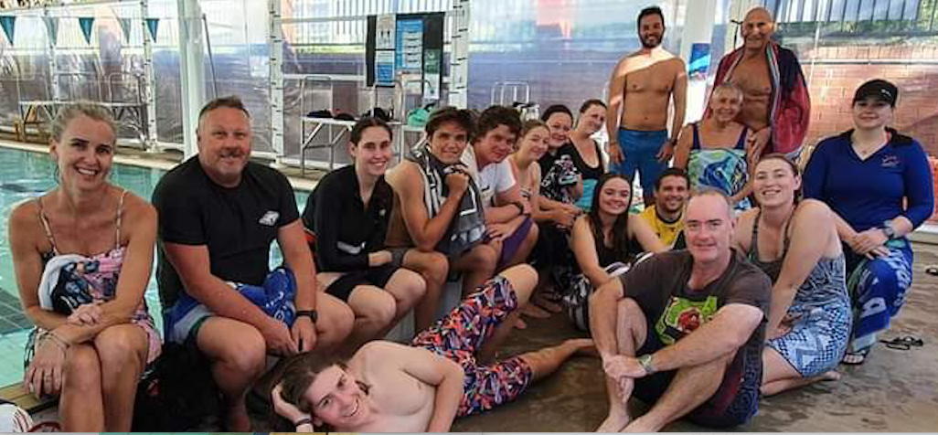
The Sunshine Coast Swim Australia Swimming Teachers Course [Image 10]

While we were doing the Swim Australia course, we heard that RLSS were launching a new Swim Teachers qualification of their own. RLSS Australia has, since 2011, long held a Swim & Survive Certification structure that includes specific aquatic competencies to directly would address many of the causes of drowning in a their learn-to-swim program. A new edition will be released later in 2021. This is a drum we have been banging at World Drowning Conferences for more than a decade, so we volunteered to take part in their pilot Swim Teachers course before the training was to be opened to the public. The ‘extras’ were a greater emphasis on learning to float and scull, survival side-stroke and survival backstroke. We were very impressed that this training emphasis begins with toddler swimming at age four and uses an attractive kids personal Log Books, similar in principle to our Sri Lanka Swim Passport concept, so that learners know what the full program ahead holds for them. Again, we were most impressed with the new Teacher Manual, staying up till 3 a.m. to complete our Theory Papers on it. Needless to say, we both passed and thus became qualified RLSS Queensland Swim Teachers as well: Four courses done.

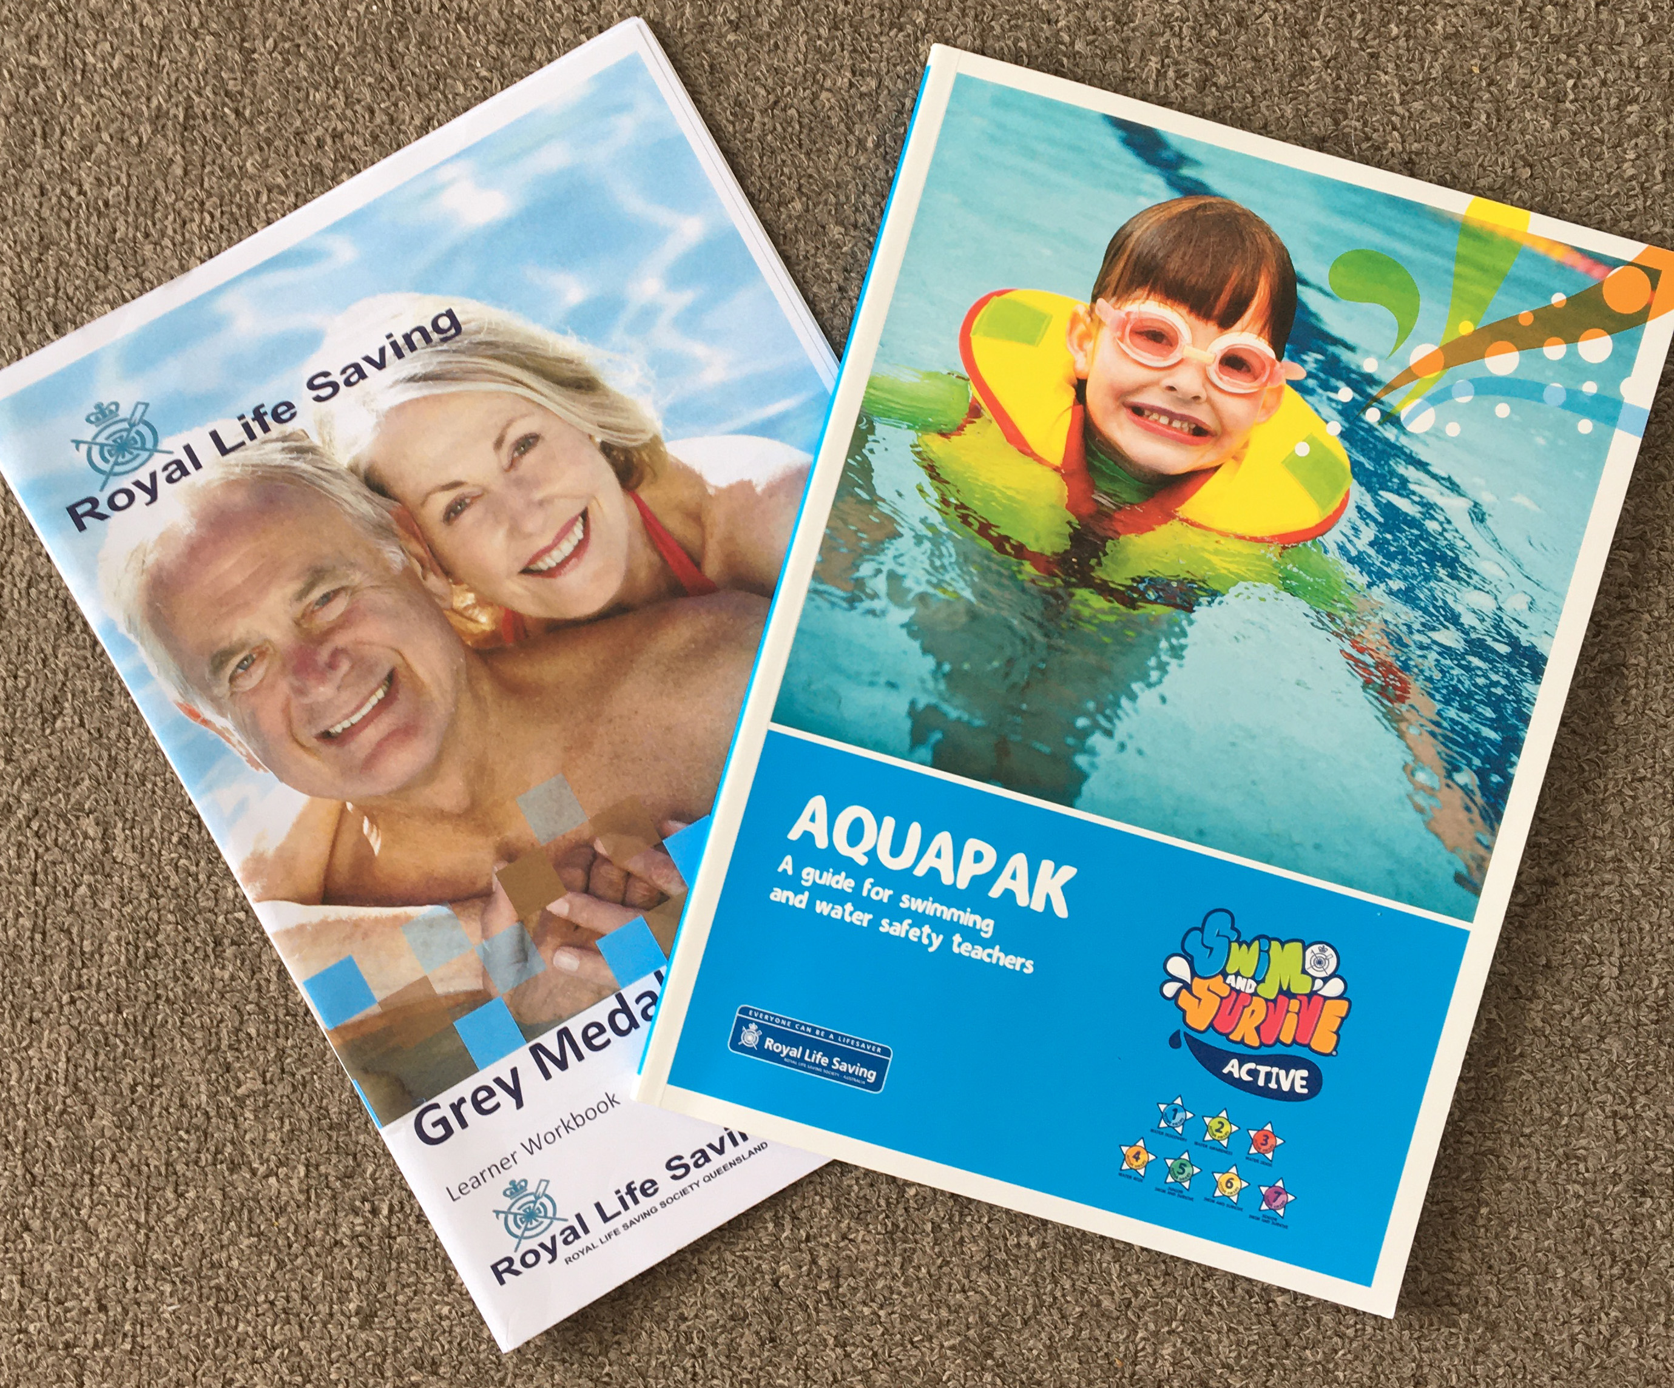
Grey Medallion and Swim & Survive Manuals

By now, the opportunity to do similar course with parallel organizations had proved to be incredibly useful in giving us an in-depth, authoritative, international perspective of the way ab-initio learn-to-swim is conducted by different organizations. Reflecting upon this, and considering the cultural inertia against women learning to swim in Sri Lanka, now that the 2004 Indian Ocean Tsunami is a fading distant memory in the face of new catastrophes, we thought that introducing Baby and Toddler swimming might be a good way to get women into water. In Asia, at least, this would be a gender-sensitive issue, so I gracefully bowed out. This would be a course for Chris alone, or rather two courses, one with Swim Australia and the other with RLSS Queensland, bringing our total to six courses. Interestingly, RLSS is like the UK STA and treats Babies and Toddlers as an extension qualification of Learn-to-Swim, while Swim Australia delivers it as a stand-alone, full teaching certificate in its own right; the rationale being that many teachers so enjoy Babies and Toddlers, they have no wish or need to teach any other group and thus specialize their careers in this field.

So, our time in Australia has been extremely well spent. We are enormously grateful to our young son and daughter-in-law for their uncomplaining support; what a strange thing it is for fit and able parents to find themselves as long term guests of their children. Hope is on the horizon: the UK has vaccinated over 17 million of its population in just a few weeks; Australia, with only a miniscule number of Covid cases, begins mass vaccination on Monday next, giving hope to us that we will soon be boomeranging our way back to Britain fairly soon, as most qualified swimming teaching septuagenarians, ready to try out Grey Medallions on our friends and Swim & Survive on our own grandchildren.
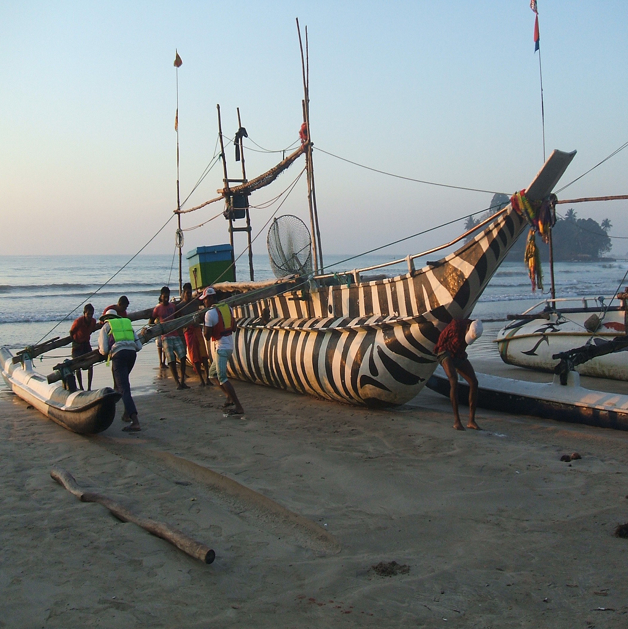
A bit different from my 70th Birthday, when I stupidly took it into my head to demonstrate a “Jump-in out-of-depth and Survival Star Float” 10 nautical miles offshore without seriously thinking how to get back aboard unassisted, around that huge hull curvature, when the boat only drew six inches! [The answer was via the outrigger and a very delicate 20 minutes inching one’s way ever further up a bent tree-trunk, , balancing in pitching and rocking waves, watched by the laughing crew.]
Broke my own Water Safety Rule: Never get in until you know how to get out!
[Experience is being habituated not to repeat doing stupid things that you survived.]
[Image 12]

Thank You, Australia.
Thank You Jamie and Jordan !

